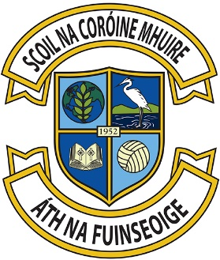

2nd of June 2016

Dear Parents,
Scoil na Coróine Mhuire’s policy with regard to the wearing of our School Uniform has been in place for many years. In 2014 the Minister asked all schools to review their policy. In line with the Minister’s request a parent survey was carried out. The results of this broadly supported the existing policy. The Board of Management has engaged with the Parent Association & Student Council.
The School Uniform is:
- Navy V-neck jumper/cardigan – crested (The old crest can be used until it filters out. New crest will be filtered in from next year. We’re in negotiation with the Crest companies to get the best deal on cresting the uniform - further details to follow)
- Navy pinafore/skirt or slacks/shorts (not denims). Leggings only permitted if navy & under a navy pinafore/skirt
- Blue shirt/polo shirt and navy socks or tights.
- Footwear which should be dark in colour.
The School tracksuit to supplement the School Uniform:
- Navy round neck sweatshirt
- Blue polo shirt
- Tracksuit pants/shorts.
- Runners i.e. shoes suitable for running, must be worn with the tracksuit.
*Branded tracksuits are not permitted.
Whilst the uniform should be worn on non-P.E. days, Photographs days & when representing the school etc., we are mindful of our lovely play areas & our facilitation of physical exercise. There will be flexibility in the Infants classes, with Senior classes with regard to the wearing of uniform or tracksuits during the months when the these classes are on the field and on occasions when children have activities/sports. This flexibility is absolutely at the schools discretion and will be communicated to the children at the relevant times.
Thanking you for your co-operation on this matter

Le dea ghuí,
Board of Management

