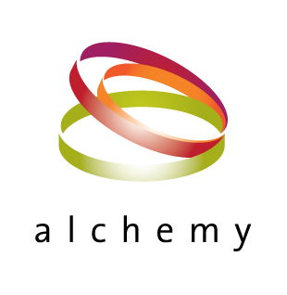
Alchemy Music Series::Wicklow
www.alchemymusicseries.com
E: alchemymusicseries@gmail.com

Féile Heaney 2015
Seamus Heaney – Celebration of a Life

Concert: Nun’s Cross Church, Saturday, 18 April, 2015 @ 8pm-9.30 pm

To celebrate the life and work of Seamus Heaney there will be a concert of music and poetry in Nun’s Cross Church on the evening of Saturday 18 April 2015.

Seamus and his family had strong links to the Ashford area – the family lived in Glanmore, his children attended Scoil na Coróine Mhuire in the 1970s and Seamus gave a memorable reading in 2011 in support of Killiskey Parish.

The 2014 Féile Heaney concert was a great success – a complete sell-out and a very special evening of music and poetry. The wonderful composer Elaine Agnew, worked with Scoil na Coróine Mhuire ‘s 4th class students to compose a new piece of music inspired by Seamus’ work which was premiered at the 2014 concert.

This year we are delighted that both Nun’s Cross and Scoil na Coróine Mhuire National Schools have agreed to follow up on last year’s work by having the schools’ 5th class students work with Elaine to compose a piece to be premiered at this year’s concert

Elaine (see www.elaineagnew.com) will visit the schools to work with the classes during the week before the concert. The concert will also include music performed by local musicians: Cormac Breatnach, Eamon Sweeney, Rachel Factor, Toni Walsh, Annette Cleary, James Mahon; and readings from award-winning poets writers Theo Dorgan and Paula Meehan.

All work with the class will take place during school hours except:

- the afternoon of Saturday 18 April – a rehearsal in the Church at 3.30pm – 4pm
- the evening of 18 April, the concert itself. The childrens’ performance will take place early in the concert. Before that they will need to arrive in the adjacent school + be supervised from 7.30 pm from where they will be accompanied into the Church for their 15 minute performance, after which they will then leave the church again to return to the school where they will be given refreshments and nibbles. They can then leave at 9pm as refreshments need to be provided for the rest of the audience for 9.30 pm. As there will be some 50 children involved it wont be feasible to keep them in the church for the duration of the performance.

Unfortunately due to restricted funds free tickets for the concert can’t be offered to the families of the students involved but instead a special adult ticket rate of €10 per adult will be apply. The normal adult ticket price is €15; tickets for children under 12 are €5. Tickets are available to purchase at Martsworth, Bridge Street Books in Wicklow Town or through your school.

If you don’t believe your child will be available to be involved in the concert it is important that that class teacher be informed as Elaine will work and compose for the forces and numbers available. All instruments will be supplied and no previous musical experience is required.

Many thanks!
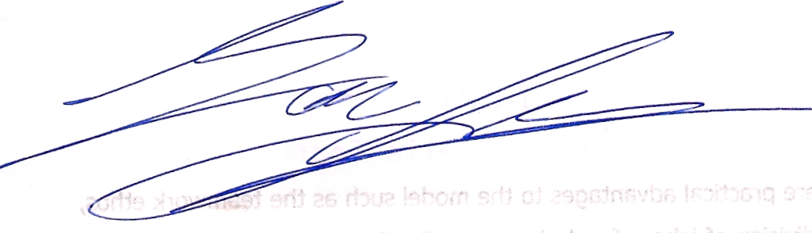
Eamon Sweeney
Co-artistic director Alchemy Music Series

